Advanced Rescue Education Solutions LLC

National Registry EMT Training Packet

Current as of - March 31, 2019
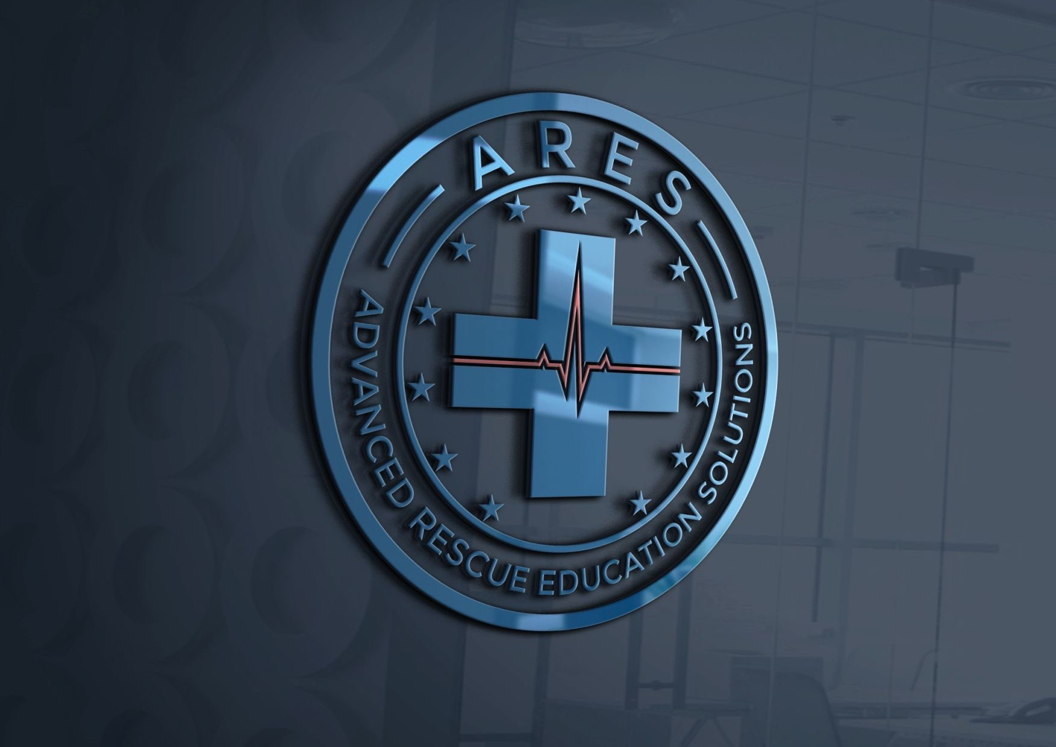

Introduction
Hello, and welcome to Advanced Rescue Education Solutions’ Emergency Medical Technician Training Course! We’re excited that you’ve chosen to enter or increase your knowledge and skills in this challenging and fulﬁlling career ﬁeld! Whether you are just becoming an EMT and embarking on your career in the ﬁeld of Emergency Medicine, or you are a seasoned ﬁrst responder looking to enhance your knowledge and response capabilities, we promise to guide you and give you all the practical knowledge we can to prepare you to save lives when they need your help the most.
Our team of EMS instructors hail from all facets of emergency response, and include paramedics, military medics, ﬁreﬁghters, and medically trained law enforcement. It is our top priority to give you the best set of tools possible in order to safely rescue people from their darkest hours and return home to your family at the end of the day.
We are glad you’ve come, and we look forward to helping you continue the work and progress of those who came before.
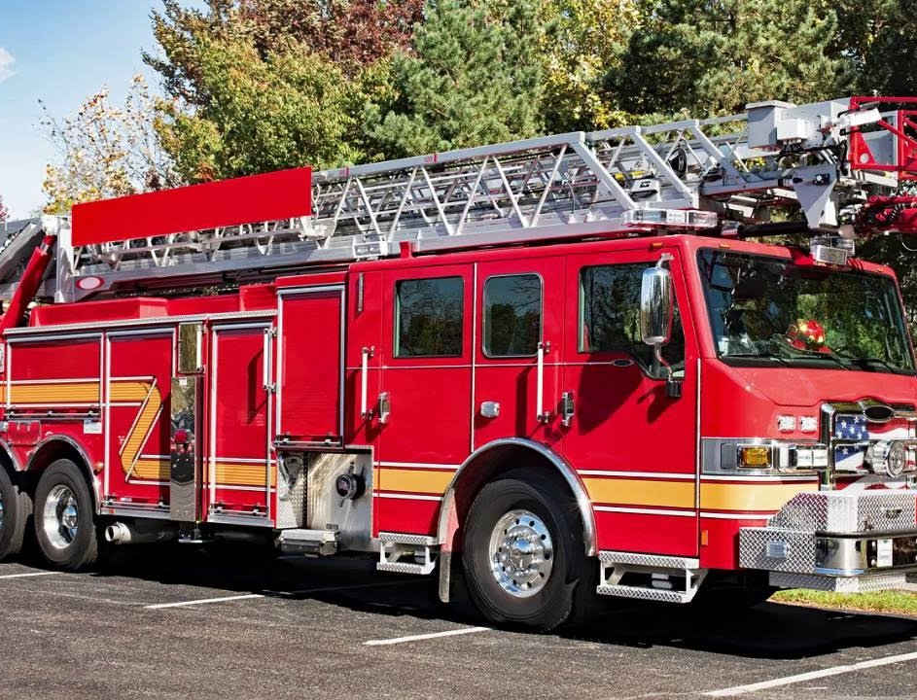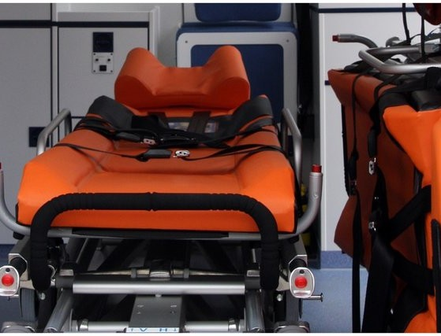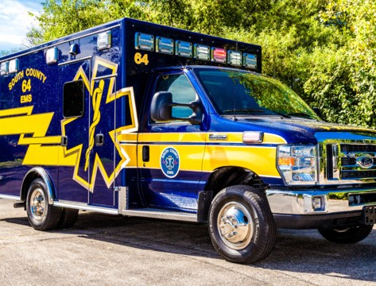

Class Speciﬁcations

Advanced Rescue Education Solutions’ (ARES) EMT curriculum is a Louisiana Department of EMS Accredited course that meets and exceeds the minimum standards set forth by the National Registry of EMTs. Successful completion of this course allows the student to schedule and attempt to pass the National Registry examination for EMT certiﬁcation, but like all programs, is only one part of the process. Upon successfully passing the National Registry examination, students will be able to apply (if necessitated by their employer or their own choosing) for state licensure in Louisiana and Mississippi as an EMT. Completion of ARES full EMT curriculum will consist of 120 hours of instruction, 24 hours of documented ride-along time with an approved ambulance provider, and 24 hours of

documented time in an approved Emergency Department. If both the student and ambulance / Emergency Department approve, more time may be allotted for further development and mastery of skills in practical applications.

Class Details

Start Date: 21 May 2019 Minimum student enrollment: 20
Partnered ambulance services: Acadian Ambulance (LA), Lifeguard Ambulance (MS)
Class Location: Poplarville Fire Department Class Hours: 1800 - 2100
Class Days: Monday and Wednesday evenings Lead Instructor: Robert Roy
Associate Instructors: Timothy Rayborn, Matt Parker

Student Requirements

Students will be required to maintain a professional appearance at all times.
Department approved uniforms are permitted when on duty. Open toed shoes, ripped clothing, lewd, generally offensive, and gang related articles of clothing are not permitted and students wearing such will be asked to leave. Students should keep comfort and serviceability in mind, as class will be a mix of lecture as well as hands on training requiring students to lift, stoop, push, pull, and come in general contact with the ﬂoor from time to time. During ambulance and Emergency Department training, students will be expected to wear approved uniform pants and collared polo shirt with ARES logo. Plain, solid color jackets and weather proof coats may be worn as seasonally necessary. Males will remain clean shaven during the course to safely maintain face to mask seals when wearing personal protective equipment (PPE).

Physical Requirements

The ﬁeld of EMS can be a physically demanding job. Lightweight training mannequins can be deceiving when real life patients can range anywhere from infants to 400+ pound diabetic patients who cannot stand up on their own power. There may be times that you are called to lift heavy patients to assist them onto the stretcher and into the ambulance. For this reason, all students will be strongly encouraged to enter into a ﬁtness program of their choice, that focuses on a blend of cardio and strength training. Proper lifting mechanics, and the strength to lift heavier patients, is integral to your success in this program and career ﬁeld; not to mention the personal beneﬁts of a healthier lifestyle. Upon completion of the program, students should be able to at a MINIMUM, lift 100 pounds, and push or pull 50 pounds.

Course Requirements

Required items for the EMT course are as follows:
Before class start date:
- High School diploma or GED (High school seniors may apply, but you must be 18 years of age and hold a diploma or GED in order to become certiﬁed.)
- FBI Background check
- Textbook or eBook
- Negative PPD (Tuberculosis) Skin Test our Chest X-Ray results
- Current immunizations record showing completion of second Hepatitis B vaccine (before clinical start date), tetanus, diphtheria, mumps, measles, rubella, inﬂuenza, and varicella.
- Valid BLS Provider through end of course.

Required Textbook and Supplies

Students will be required to purchase a stethoscope for use during laboratory sessions and clinical rotations. Purchase of a blood pressure cuff is encouraged since manual BP cuffs often are not readily available at rotation sites.

Textbook: Emergency Care, 13th Edition (Limmer, D. & O’Keefe, M. F.).

The textbook is offered as an eBook at a lower cost than the paperback book. We recommend this option, if a student has an available device to load it on, due to the cheaper cost, eco friendly, and faster reference ability due to inherent search functions.

Course costs and associated fees

Criminal background check (if not already completed): $80.00 Tuition: $600.00*
CPR: $60.00**

*Fire Department personnel receive a $100.00 discount for this class only.
**CPR certiﬁcation must be current through end of EMT course, and must be American Heart Association’s Healthcare Provider BLS. If students are already current through the length of the course, this fee will be waived.

Disability Accommodations

ARES will take the steps required for reasonable accommodation to ensure that no individual is excluded, denied service, segregated, or otherwise treated differently than other individuals because of the absence of auxiliary aids and services. Support assistance may include note takers, interpreters for the deaf, tutoring, counseling and advising, special arrangements, tape recorders, etc. Persons requesting disability services should complete a request for services by contacting the main ofﬁce. In many cases, recent documentation of

disability may be required. The National Registry of Emergency Medical Technicians administers a separate process for determining whether accommodations for disabilities will be granted during the certiﬁcation exams. Eligibility is determined on a case-by-case basis.
Therefore, a student who receives an accommodation during an EMT course has no guarantee of receiving an accommodation for the certiﬁcation exam.

Health Insurance Disclosure and Agreement

The profession and activities that you will undertake as part of your educational experience will expose you to risks. The dangers include, but are not limited to, ambulance crashes, assaults, hazardous materials exposures, infectious diseases, lower back injuries, abrasions, cuts, and exposure to extreme temperatures.
Students are provided liability insurance through ARES for the purposes of the clinical rotations only. This is not health insurance and does not equate to medical beneﬁts. The facilities in which you will be learning do not provide worker compensation or other medical beneﬁts to the student.
If the student becomes sick or injured as a result of participating in the EMS Profession courses, the student will be responsible for any and all costs that are associated with the treatment. As such, students are highly encouraged to purchase personal health care coverage while participating in these courses.
Some clinical facilities require students to provide evidence of a current policy to participate in clinical experience at their location. This will not prevent students from completion of the program, but does limit the number of sites available for student without health coverage.
I understand that Advanced Rescue Education Solutions (ARES) and afﬁliated clinical sites have no responsibility for providing health care services in the event of illness or injury. In addition, students may be requested to acknowledge and sign additional liability release forms from clinical sites.

Date: Signature: Printed Name:

